**Feature 5 – Website Information Page**

**As an** a user of the website **I want** to have a home page that is tailored to the functions I can use **so that** I can be directed to my areas of interest.

**Summary**

A home page that shows what functions can be used by the specified user. The options will vary for the owner (Mika), a teacher, and a student.

**Acceptance Criteria**

When the owner is logged in, the functionality shown will be as follows:

* See ALL teacher information[1]
* See ALL student information[2]
* Enrolment contract
* Instrument Inventory
* Produce Reports

When a teacher is logged in, the functionality shown will be as follows:

* See INDIVIDUAL Teacher Information

When a student is logged in, the functionality shown will be as follows:

* See INDIVIDUAL Student Information
* Book Lessons
* Request Lesson Change
* Instrument Hire

When a new user who is NOT logged in, the functionality shown will be as follows:

* Create new Teacher Form[3]
* Create new Student Form[4]

‘About the School’ information will be detailed at the bottom.

**Description**

This is the home page that will direct the user to other elements of the site that the user is authorised to access.

It is the page that will appear after login (if login is implemented) and will be an option on every page thereafter to return to this home/main page.

It should only show the functions that are allowed to be accessed by the particular user that is logged in. If the login feature has not yet been implemented, it will be designed for the owner (Mika).

**Potential Design Implementation**

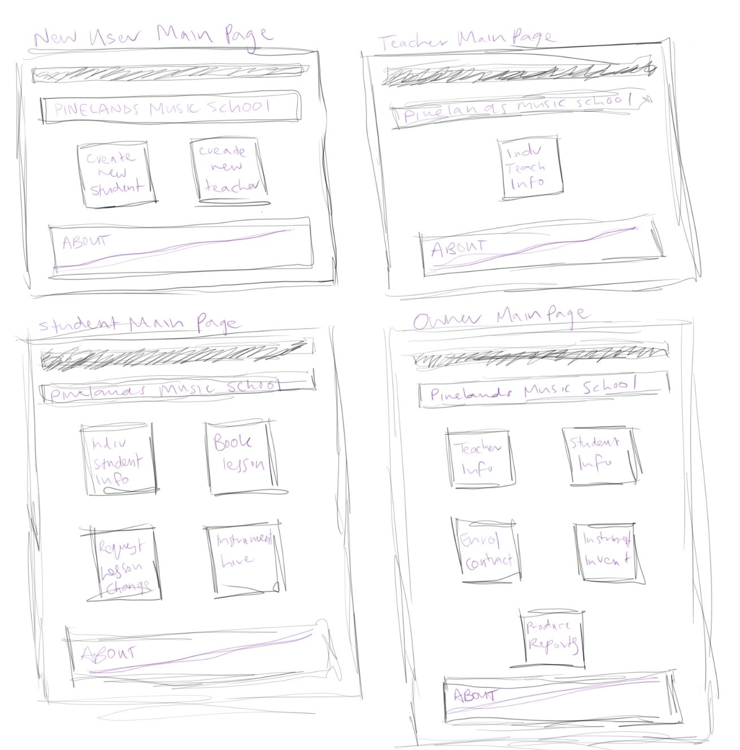

**Test Cases**



1. Need to create a new user story/feature relating to browsing teacher information
2. Need to create a new user story/feature relating to browsing student information
3. Add functionality to create new teacher form – new username and password
4. Add functionality to create new student form – new username and password